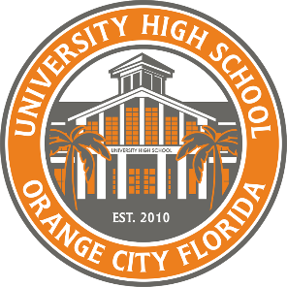
1000 Rhode Island Avenue
Orange City, Florida 32763

386-968-0013

Karen Chenoweth
Principal

January 3, 2022

University High School will be offering a unique opportunity for High School Seniors who have yet to earn a passing score on the FSA ELA and/or Algebra 1 EOC or obtain a concordant score using the ACT or SAT, to sit for an “in school ACT” test administration. This special administration will allow students the potential to earn a concordant score needed for a standard high school diploma. Students who choose to use this “in school ACT” test option will only be permitted to use these scores as a concordant score for graduation purposes.
The ” in school ACT” test administration cannot be used for:
  - Bright Futures
  - College Admissions
  - Scholarship Opportunities

The “in school ACT” test administration will occur on March 7-9, 2023. Your student has been selected to participate in this opportunity in hopes of obtaining a concordant score. There is no cost to your student to take this test, however you must sign and return this letter to Kristina Derstine by Friday, March 3, 2023.
Student’s Name, Grade, and Alpha _____________________________________________

Parent/Guardian signature __________________________________________________

Thank you,
Kristina Derstine
khdersti@volusia.k12.fl.us
Testing Coordinator

“Follow the Creed: Knowledge, Courage, Strength, and Respect”

